Sanity Check:::

Dir ii = 1

>> kp = ptStartInd:ptEndInd;

>> binX = 0:.005:2;

>> binY = binX;

>> distan = totalEdgDist(kp) ;

>> [n,~,~,ix] = histcn(points,binX,binY);

>> kpp = all(ix>0,2);

>> mean_dist = accumarray(ix(kp,:),distan(kpp),[],@nanmean,nan);

>> figure

imagesc(mean_dist)

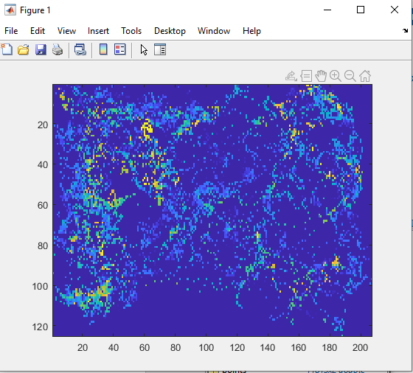

Ii = 2

Using same ^^

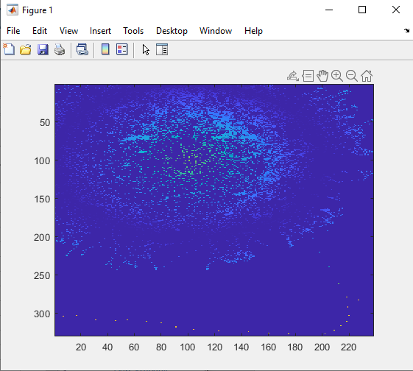

I = 3

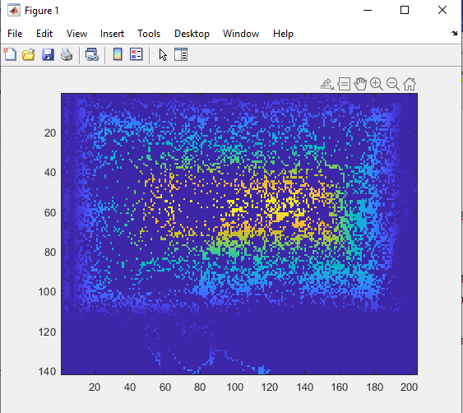

I = 4

binX = -1:.005:2;

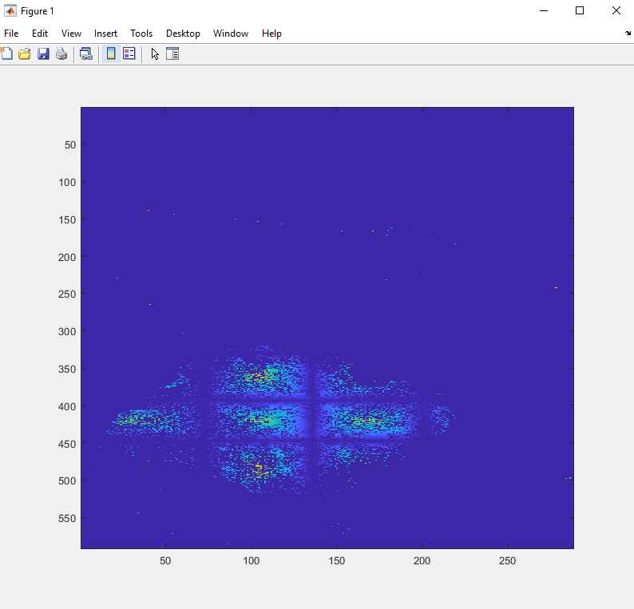

I = 5

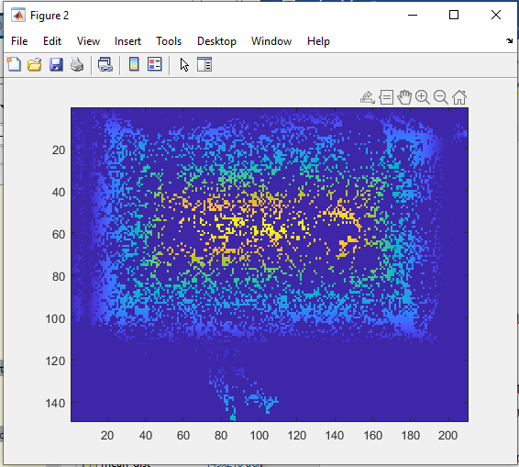

I = 6

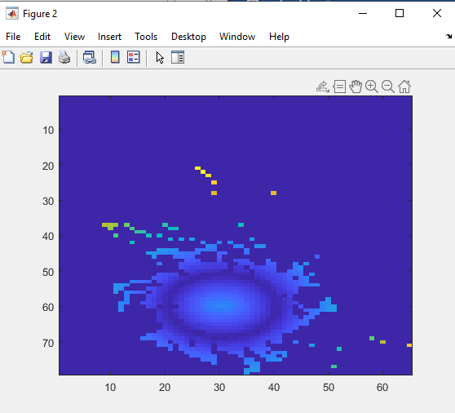

I = 7

